 | Calendar
Apr 21 | Pickleball - Sunday | 6:00
Apr 22 | Food Pantry at Community Service | 4:00
Apr 22 | Pathfinders | 5:30
Apr 23 | Community Services Open Tuesday | 2-5
Apr 23 | Pickleball – Tuesday | 6:30
Apr 24 | Prayer Meeting – EW 54 | 6:00
Apr 24 | Church Board at Lafollette Church | 7:00
Apr 25 | Community Services Open Thursday | 9-1
Apr 25 | Pickleball – Thursday | 6:30
May 3 | Communion | 11:30
Birthdays – April 21 – Carolyn Towles
April 21 – Eddie Towles II
April 26 – Kimberly Claxton

Church Budget
Monthly Budget | $9,830.00
Month to Date 04/19/24 | $2142.99
Under Year-To-Date | $9,808.67
Remember Online Giving!

Other Financial Needs:
Springs of Life - $200/mo.
“He Looked Beyond My Fault”
April 20, 2024
Jellico Christian Radio 96.5 FM $350/month.

Next Sabbath
April 27, 2024
Speaker | Pathfinders |  | Song Leader | Kerri Boone
Elder | Chris Spinolo |  | San. Teacher | Bob Penn
Offering | Cohutta |  | Potluck | Spaghetti

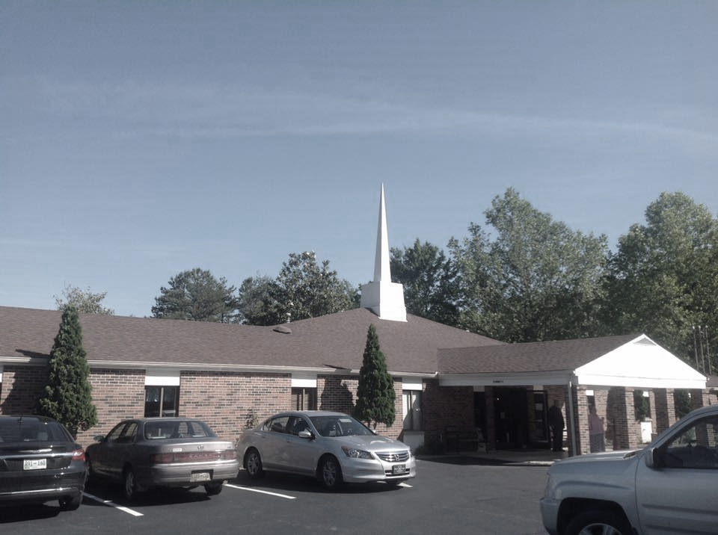
Jellico
Seventh-day Adventist
Church
“He Looked Beyond My Fault”
Jellico SDA Church
April 20, 2024

Announcements |  |  |  |  |  | Darryl Wilkens
Prelude |  |  |  |  |  | Karen Pires
Call to Worship |  |  |  |  |  | Darryl Wilkens
Opening Hymn |  |  | “Lord, in the Morning” |  |  |  |  |  | #39
Pastoral Prayer |  |  |  |  |  | Darryl Wilkens
Offering |  |  |  | Church Budget |  | Darryl Wilkens
Offertory |  |  |  |  |  | Karen Pires
Doxology/Prayer |  |  |  |  |  | Darryl Wilkens
Special Music |  |  |  |  | Pastor Pires
Sermon | “He Looked Beyond My Fault” |  |  |  |  |  | Pastor Pires
Closing Song |  |  |  |  |  |  |  | K & K
Closing Prayer |  |  |  |  |  | Pastor Pires
Postlude |  |  |  |  |  | Karen Pires

Sunset Today: 8:15 pm Sunset Friday: 8:20 pm

Welcome to the Jellico Seventh-day Adventist Church. We hope you have a blessed Sabbath! Please join us for a Fellowship Meal in the gym.

Bulletin Secretary is Cheryl McDaniel – Please text bulletin information to 423-494-1532 by Thursday evening.
Announcements

Food Pantry – April 22 at 4 pm. Helpers, please be there at 3 pm.
Pathfinders – April 22, 5:30 pm.
School Fundraiser – Please see the sign up in the lobby for the JCA Petunia Fundraiser!

Isaiah 41:10 - Fear not, for I am with you; be not dismayed, for I am your God; I will strengthen you, I will help you, I will uphold you with my righteous right hand.

The Prayer Corner
Please Pray For Be Thankful for
Craig and Karen Taylor as they face moving challenges and life in a new place!  Evangelistic meetings that Elder Green is leading out in Jackson, KY.  Donna McCulley’s Mother in end of life scenario.  Family in the death of Candace Anderson’s Mother.  Serena and Charity to make good decisions.  Vicky for healing. |  | Safety on the Roads.  Dr. Escalante’s Mother is doing better!  Doug Milburn is recovering from back surgery!  Bible Study Students!  Friend of Rick Greve is improving from back surgery!  Spring and warmer weather!

